**Data Visualization for Analytics**

**Final Project**

**Anushareddy Ramachandra Reddy**

University of North Texas

Spring 2024

# Professor: Dr. Chih-Hao Ku

**Aircraft landing facilities in USA**

# Introduction and Background Motivation

The inspiration for our project on "Aircraft Landing Facilities in the USA" traces back to a chilling incident at the start of the new year in Japan, where an aircraft was severely damaged in an emergency landing, leading to massive disruptions. Thankfully, severe injuries were averted, but the event highlighted the critical importance of advanced and efficient landing facilities. This incident, covered extensively in global aviation reports, underscores the thin line between a controlled emergency response and a potential catastrophe. It led us to ponder the robustness of aircraft landing infrastructures and their role in mitigating such crises. Our research is driven by a need to understand the underlying factors contributing to aircraft landing safety and how improved facilities can enhance overall aviation safety.

# Context and Relevance

The project focuses on airport landing facilities in the United States, a critical aspect of aviation infrastructure. Safe and efficient landings are essential for smooth air traffic operations, preventing accidents, and safeguarding passengers, crew, and cargo. As air travel increases, assessing and enhancing landing facilities becomes crucial. The study is relevant to recent aviation incidents, industry safety reports, and growing public and regulatory demand for heightened aviation safety standards. The project contributes to a critical understanding necessary for advancing safety protocols and infrastructure by analyzing the current state of aircraft landing facilities.

# Objectives and Queries:

**Objectives:**

Our project aims to comprehensively assess the state of aircraft landing facilities across various airports in the USA. We seek to understand the spectrum of existing infrastructures, identify critical shortcomings, and highlight best practices. Our project aims to achieve several objectives:

* Assess which states or cities have landing facilities for different aerial vehicles (aircraft, helicopters, ultralights) and correlate these facilities with local demand.
* Analyze the current state of airport landing facilities across the United States.
* Identify factors that may contribute to aircraft failures during landing operations.
* Identify areas with limited passenger traffic and propose development strategies for their landing facilities and services.
* Explore correlations between airport infrastructure, weather conditions, and aircraft incidents.
* Propose recommendations for enhancing the safety and efficiency of aircraft landing facilities.

# Queries to be addressed:

* How do Aircraft Landing Facilities Impact Regional Accessibility and Economic Activities?
* Operational Capabilities and Aviation Support at U.S. Landing Facilities.
* Analysis on each landing facility type.
* State wise Air Travel Insights - Which state recorded the highest level of air travel enplanements and how does it compare to the passenger traffic and arrivals/departures?
* Can we replicate the infrastructure and services in other cities to enhance passenger traffic and improve landing capabilities?
* What is the distribution of different types of landing facilities (airports, heliports, etc.) across the states?
* How does the availability of control towers correlate with the volume of air traffic (local, itinerant, military operations)?
* What types of facilities (international, supports jet engines, customs landing rights) are available in each FAA region?
* Impact of facility type on passenger and aircraft movements?

# Benefits:

The potential impact of our project is manifold. Firstly, it could significantly contribute to the academic and industry discourse on aviation safety, providing empirical insights into the current state of landing facilities. For policymakers and airport authorities, our findings can inform

decisions on infrastructure investment and safety protocol enhancements. Moreover, our research can aid in developing predictive models for assessing and mitigating risks associated with aircraft landings, ultimately contributing to safer air travel for passengers and the aviation industry.

**Datasets:**

**Origin and support:**

The Homeland Infrastructure Foundation is the original author of the dataset, which was discovered on the Kaggle website. The dataset ensures a comprehensive analysis by the features of landing facilities in various locations. It includes landing locations throughout several US states, counties, and localities, making it easier to analyze regional trends.

Source: <https://www.kaggle.com/datasets/thedevastator/usa-aircraft-landing-facilities>

**Variable Insights:**

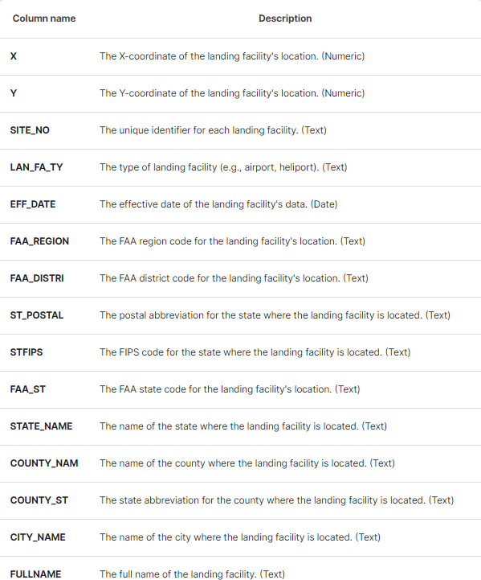

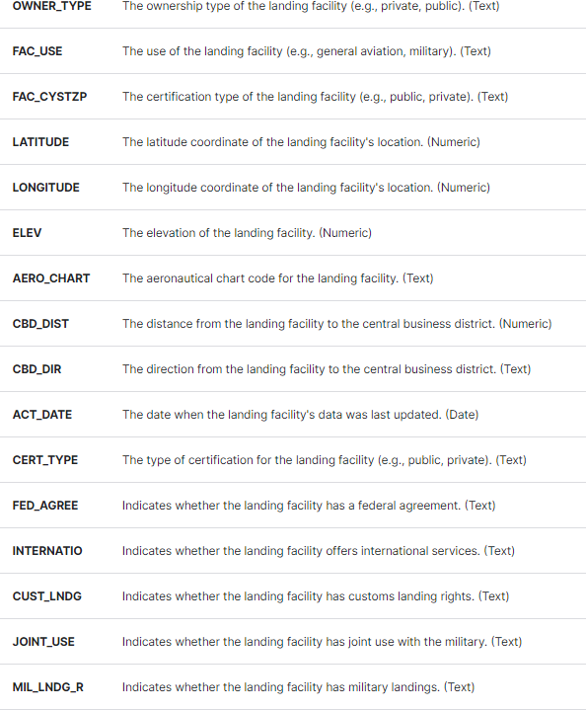

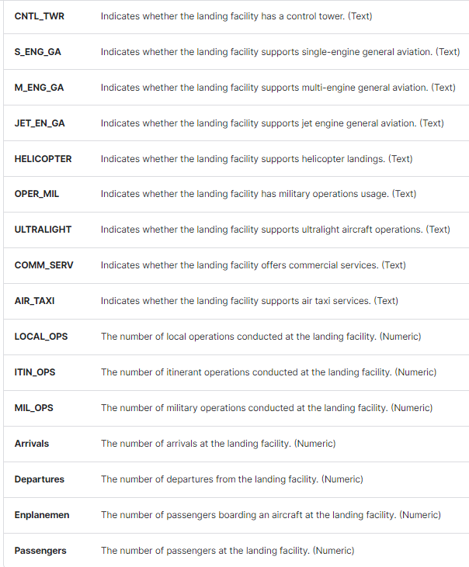

# Scope and Dimension:

The dataset shows a significant size, with several columns offering extensive information like geographic coordinates, ownership kinds, facility utilization, operating statistics, and passenger data.

The geographic coverage includes information on the counties and cities where landing sites are in addition to specific states. This wide coverage makes it possible to conduct analyses that consider regional variations and trends in the availability and use of landing facilities.

The dataset shows data collected over a period, encompassing a range of effective and active dates. Because they offer temporal references, variables like "EFF_DATE" and "ACT_DATE" enable analyses to take landing facility data updates and modifications into account.

# Utility and Constraints:

The project's goals of evaluating landing sites, spotting regional differences, and investigating variables affecting aviation services and infrastructure development are all closely aligned with the datasets. They offer the information required to answer important research questions and produce insightful conclusions.

The datasets provide a wealth of information, but there can be restrictions on the completeness of the data. To lessen these restrictions and guarantee the accuracy of the analyses and conclusions, comprehensive evaluations of the data quality and validation procedures are crucial.

# Data cleaning and Preprocessing:

The jumbled data was split and mapped using the primary keys. Null values were removed for improved calculations, the column name was changed, the data type was altered, and duplicates were eliminated using a calculated field. All null values and unnecessary variables were eliminated using Tableau's filter tool.

Using Python Code, Filters, Calculated fields

* Observed the frequently used 6 columns have many abnormalities and missing values, so for each column with respect to its raw data and importance we have filled the missing values with mean data and zero, also dropped null values.
* Passengers, Arrivals, Departures – “Mean” and Local, Mil, ITIN ops, CBD_Dist – “0” **Filters:** State Region, LAN FA Type, FAA region have null values which were removed through filters.

**Data Stories**

**First Dashboard - Top 10 Cities with aircraft landing Facilities**

# Can we replicate the infrastructure and services in other cities to enhance passenger traffic and improve landing capabilities?

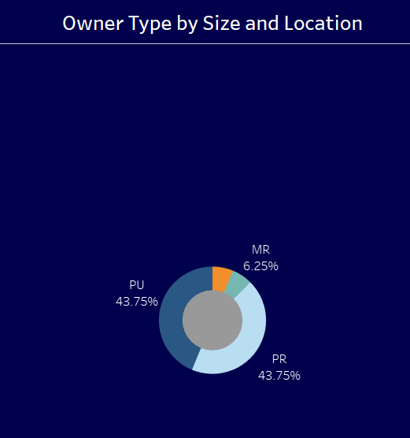**Viz - 1: Owner type by size and location**

This pie chart visualization shows how the "Owner Type" is distributed geographically and in terms of size after being filtered for states or regions designated as "DIST. OF CO."Three slices make up the pie chart, each of which represents a distinct owner type category:DU stands for Dark Blue. This portion of the pie chart makes up 43.75% of the total.

PP (Gray): This slice occupies 43.75% of the entire pie chart, just like DU does.

MR (Orange): This slice makes up the remaining 6.25% of the entire pie chart.

According to its title, "Owner Type by Size and Location," this graph displays information about the types of companies that own different properties, etc., and is arranged according to both their sizes and geographic areas within the "DISTRICT OF COLUMBIA" region.

This visual representation of a pie chart illustrates the distribution of different certificate types according to their geographic location and relative magnitude.

# Viz - 2: Certification type

Each slice in the pie chart represents a category of the Cert type, and each one also has a date or year value that could reflect the certification's issuance or expiration date:

I B S 05/1973 - 18.18% (Light Blue). 4.55% of I V A U 01/1985 (Red).

4.55 percent of I V A U 12/1974 (Green) shares.

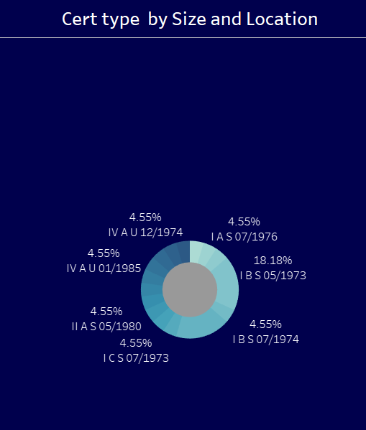I A S 07/1976 (Pink): This slice accounts for 4.55 percent of the total and is of the same size as the last three slices.

The remaining slice, which has a gray tint and a bigger amount of the pie chart than the others up to 18.18% is not identified with any date or Cert type group.

The graph's title, "Cert type by Size and Location," suggests that the different licenses and certificates we see here are categorized based on their size and the location in which they were issued the region labeled "NEW Y," which is likely to be New York state.

# Viz - 3: Aero Chart

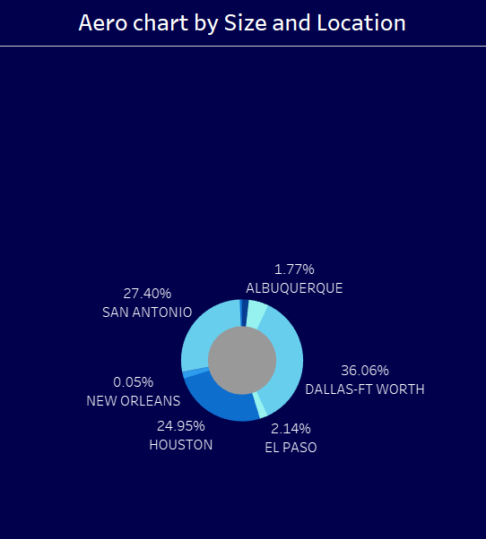The graphic displays a metric's distribution across several areas or localities in Texas. "Aero Chart by Size and Location" is the name of the tool. This suggests that the information displayed represents aerospace and aviation activity categorized by area and size.These pie slices, each representing a distinct Texas city or place, make up the pie chart:Dallas-Ft Worth (Gray): The largest pie slice, making up 36.06% of the total pie.

The Houston (Orange) slice makes up 24.93% of the total pie pieces. San Antonio (Light Blue): 27.40% of the pie pieces are

made up of this slice. Albuquerque (Light Green): This amounts to a mere 1.77% of the whole pie. El Paso (Dark Green): The smallest portion, making up just 2.14% of the total when all the other slices are added together. New Orleans (Dark Blue): This small portion makes up only 0.05% of the total area of the diagram.

We can infer that, within Texas Dallas-Ft Worth, Houston and San Antonio have the highest quantities or shares for this metric, while Albuquerque and El Paso fall into lower categories, with New Orleans being almost negligible in relation to aggregate data, even though this chart lacks specific information about what is being visualized.

# Viz - 4: Top-10 Cities

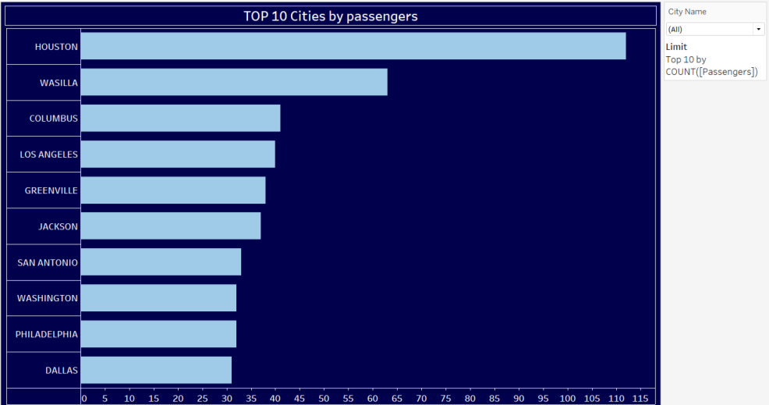

The top ten cities with the most passengers are displayed in this sideways bar chart. Names of cities are on the y-axis, while the count or metric being measured—likely the number of passengers is on the x-axis. The largest bar on the map, which extends from left to right, stands for the state or city with the most passengers. They can be arranged as follows, tallest to shortest, based on the lengths of the bars:

HOUSTON (most passengers – longest bar)

Dallas has the smallest bar among the top 10 and the fewest members of this category.

# Viz - 5: Count by City

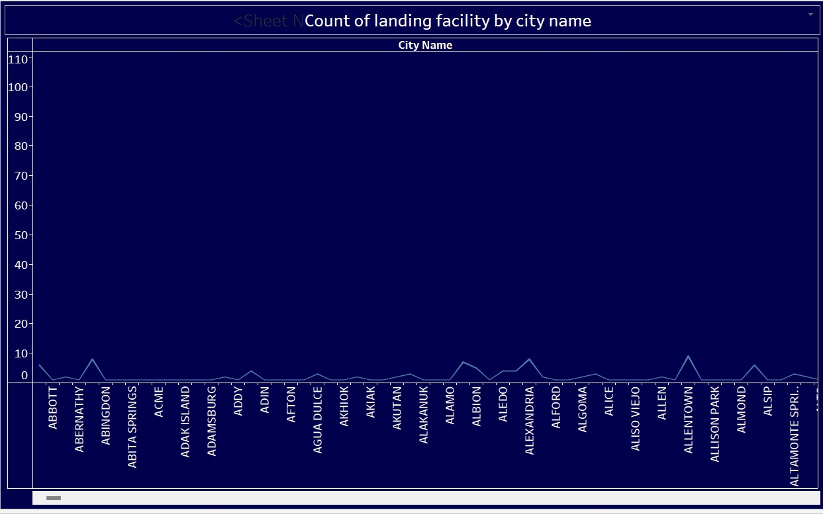

The total number of "Air Taxi" operations across all landing facility types is visualized in this bar chart. The x-axis shows the categories for various landing facility types, and the y-axis shows the totaled or tallied figures for "Air Taxi" operations. The "AIRPORT" segment of the bars is colored differently from the other sections due to its higher value than any other category shown in this chart. The bars have been color-coded.

In summary, this image illustrates the relative frequency with which air taxis use various types of landing facilities. This makes it easier for us to identify the kind of locations that often see greater or lower volumes of air taxi operations.Users can pick individual state names using the filter on the left, which may allow them to perform more in-depth study on air taxi activities by state and kind of landing facility.

# Viz - 6: Count of passenger by location

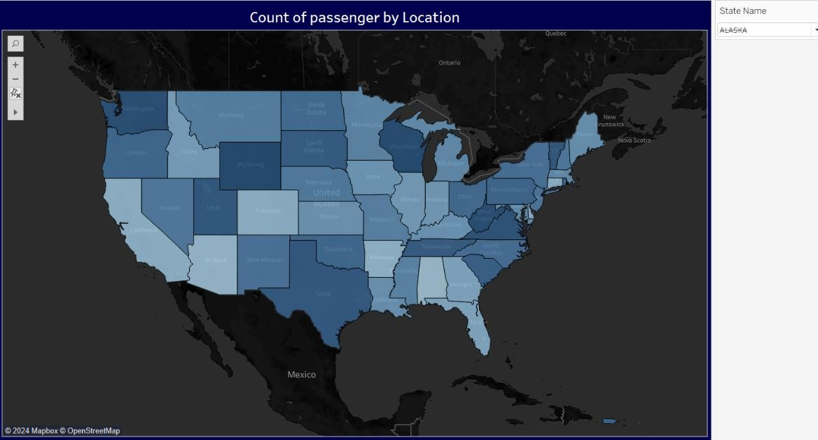

Users can filter and examine numerous metrics connected to air travel statistics by using the interactive choropleth map of the United States, which uses varying shades of blue to depict the number or sum of passengers by location or state. The map of the continental United States displayed in the visualization is colored by the value of "SUM(Passengers)," which could represent the total number of passengers in that state. Lighter blue hues denote lower values, whereas darker blue hues suggest higher values.

Additionally, there are filters on the left side that allow users to filter based on "State Name," "Latitude," "SUM (Passengers)," and "Longitude." With the help of these filters, it is possible to

examine passenger counts that correspond to particular states or regions. Visualization can be utilized to display additional information about each condition or location by providing additional markers or visual encodings, such as color, size, labels, tooltips, etc. through visualization.

In conclusion, this representation makes working with statistics enjoyable. It is a practical tool for intuitively examining passenger data on air travel between various US states or locales.

# Viz - 7: Landing facility

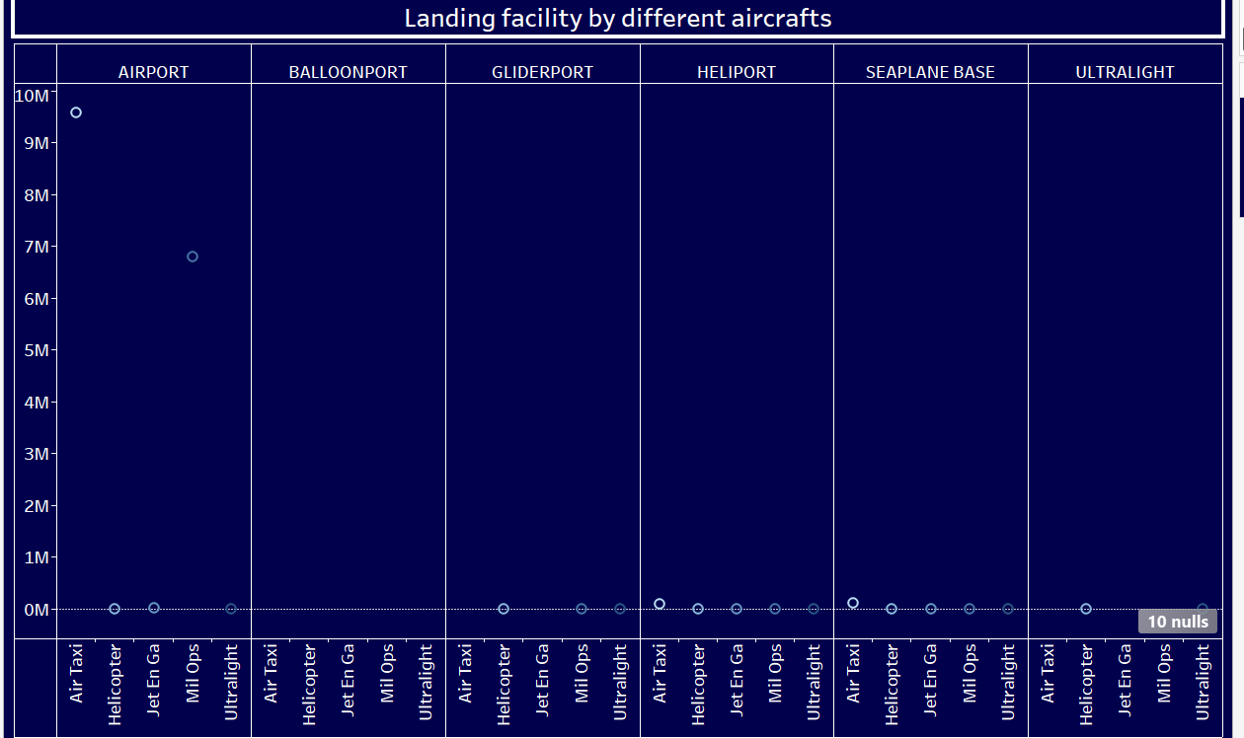

The length of the colored bar for each type of landing facility represents the total number of operations or activities associated with that particular aircraft type. For instance, a high count or total for airport air taxi activities is indicated by the lengthy blue bar for AIRPORT.

Comparing the relative activity levels or operating counts for various aircraft types across the different types of landing facilities is made simple by the display. It offers information about which aircraft types are more common or have higher numbers at particular kinds of facilities.

The graphic also shows scatter dots or circles, which stand in for possible outliers or extreme results for particular aircraft types and landing facility combinations.

Users can determine the appropriate colors for each category by referring to the legend located on the right side of the chart, which lists the various measure names or aircraft types that are being plotted.

# Dashboard:

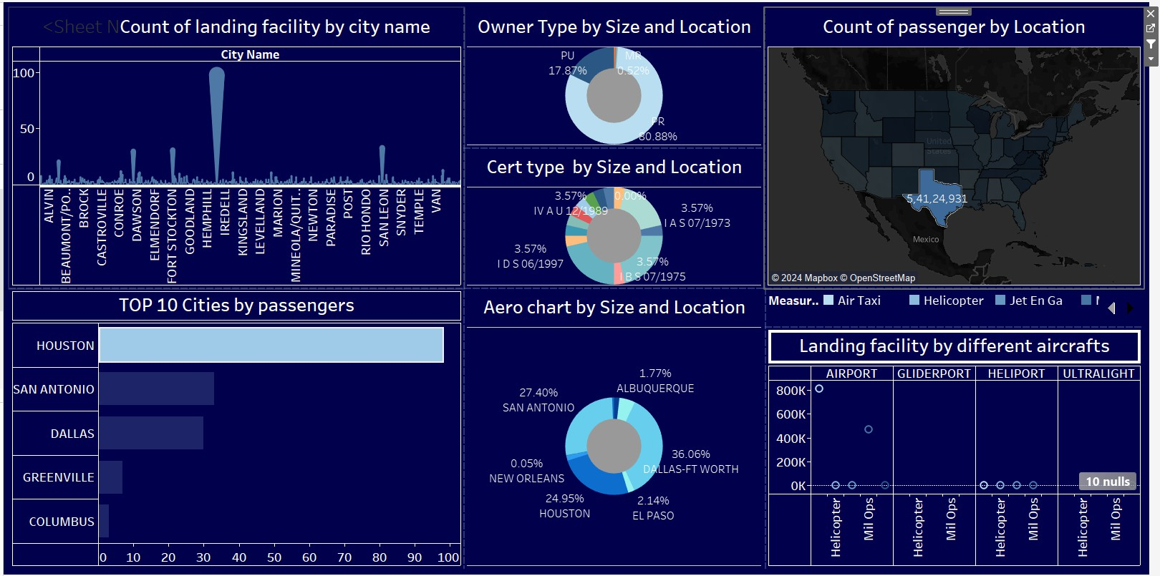

This instrument provides a logical view of plane landing places over the top 10 cities in a specified area or country. Let’s connect the dots among the different visualizations to understand what they are trying to tell us.According to the chart “Top 10 Cities by passengers,” Houston has the most passengers, followed by Wasilla and Columbus. This means that these cities may have major airports or see heavy air traffic, which can be related with available landing facilities number.

The bar chart “Count of landing facility by city name” confirms this observation as it shows that Alvarado is number one when it comes to quantity among indicated towns, followed closely by Bear Lake and Brookshire. In terms of location and size depicted on pie charts called “Owner Type by Size and Location,” majority (80.88%) of landing facilities within this area are privately owned compared to public ones accounting for only 17.87%. The chart of "Cert type by Size and Location" gives us an idea of the sizes these landing facilities come in as well as what they can do. The “Aero chart by Size and Location” reinforces this point with San Antonio (27.40%) and Dallas-Fort Worth (36.06%) being the only major airports represented on it – others such as New Orleans (0.05%) likely have smaller regional airports or airfields.

**Second Dashboard: State wise Air Travel Insights**

# Which state recorded the highest level of air travel enplanements and how does it compare to the passenger traffic and arrivals/departures?

**Viz-1 : Enplanement by State**

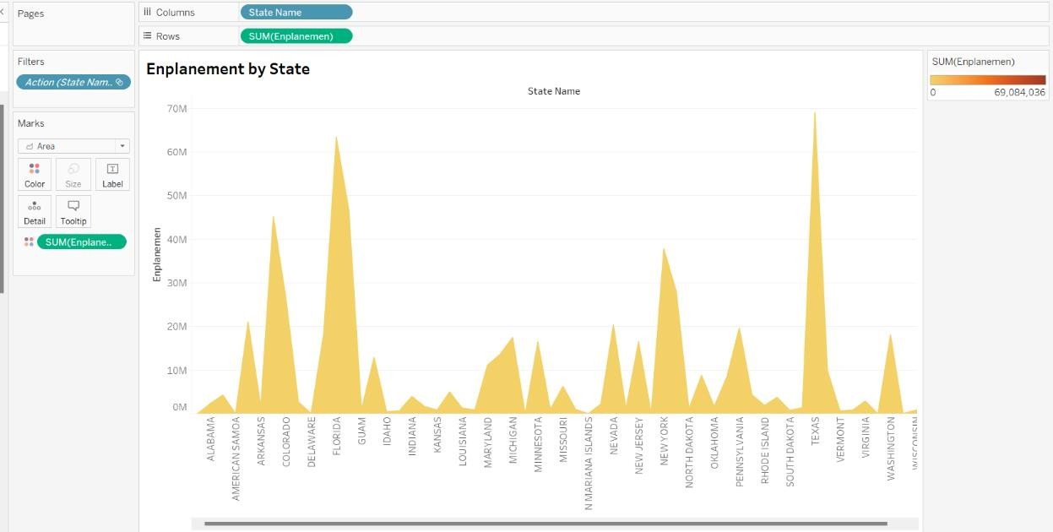

Enplanement by State: The total number of passengers enplaned by state in the US is shown in this chart, "Enplanement by State," which was generated as a visualization. The data range shown on the right-hand side of the chart, which spans from 0 to roughly 69 million, suggests that the y-axis quantifies enplanements. The x-axis lists various U.S. states alphabetically from Alabama to Wyoming. The graph shows how many people leave from each state with noticeable spikes like Texas and Florida indicating high amounts of air traffic. All things considered, this visualization does a good job of conveying the variation in air travel activity throughout the United States, making it easy for viewers to identify which states have higher or lower levels of air passenger flow.

# Viz – 2: Passengers by State

This visualization called “Passengers by State” is a bubble chart that shows how many people leave different states of America. The purpose of this tableau bubble chart is to do a visual comparison between states on the basis of passenger volumes.

The total number of passengers from every state is shown by the size of each circle, or bubble, on the chart. Each circle represents a state. Larger bubbles indicate more passengers while smaller ones represent fewer individuals. It could be that the orange color gradient used in the chart is just for decoration and does not convey any additional information.

Data labels appearing inside or beside the bubbles indicate which state they represent as well as how many people travelled through it. For instance, Texas has one of the biggest bubbles labeled “54,124,931” implying that it has among highest numbers of visitors among all states. Similarly large bubbled and highly occupied places can be found in other prominent states such as Florida and California too. Consequently, this visualization gives an instantaneously arresting visual impact which can help identify national passenger data’s regularities and peculiarities at one glance.

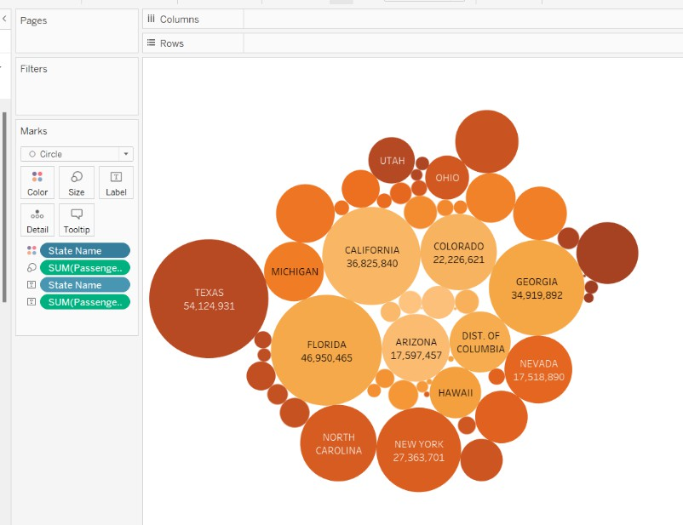

**Viz - 3: Departures by State:** This is a treemap called “Departures by State” that illustrates the number of departures from different states in the USA. The size of each rectangle corresponds to a quantitative variable, which in this case is the number of departures. Therefore, it allows for quick comparison between categories.

Each rectangle represents one state and its area represents how many flights left there altogether. Smaller boxes stand for lower numbers while bigger ones indicate more significant amounts.

It’s not surprising that Texas, California or Florida are marked by large rectangles as they have huge populations and numerous airports serving as major hubs. Among other active regions we can find e.g., North Carolina, Colorado or New York.

The overall distribution across America can be easily grasped thanks to this treemap – it shows where air travel is most popular within the country, what can be treated as an indicator of business connections, tourism attractiveness or economic vibrancy etc.

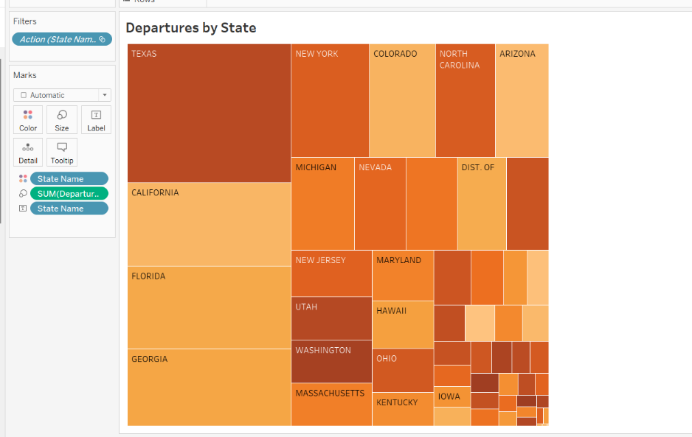

# Viz – 4: Arrivals by State

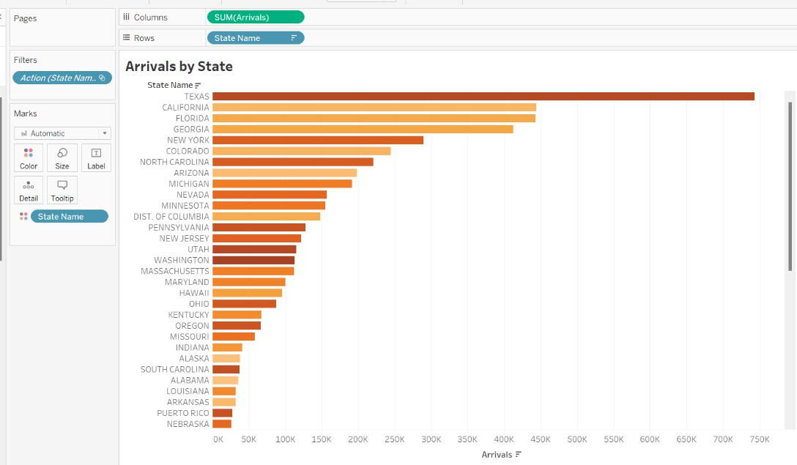

This visualization called “Arrivals by State” represents the number of arrivals in different US states by using horizontal bar chart. The x-axis shows the amount of arrivals, which can be indicated by thousands as seen from 750,000 point numerical scale. Arrivals ranking state-by- state within the US is displayed on the y-axis.

The size of the bar indicates how many people arrived and each bar represents total arrivals for particular state. Though it does not explain why colors are changed exactly, but an orange color gradient of this graph is used to emphasize or accentuate disparities in data presentation.

Among others were findings that states having highest immigration numbers recorded longest bars; these include California, Texas and Florida among others too. This might be because they act as major transit points with large populations as well popular tourist destinations

# Dashboard - State wise Air Travel Insights

**Which state recorded the highest level of air travel enplanements and how does it compare to the passenger traffic and arrivals/departures?**

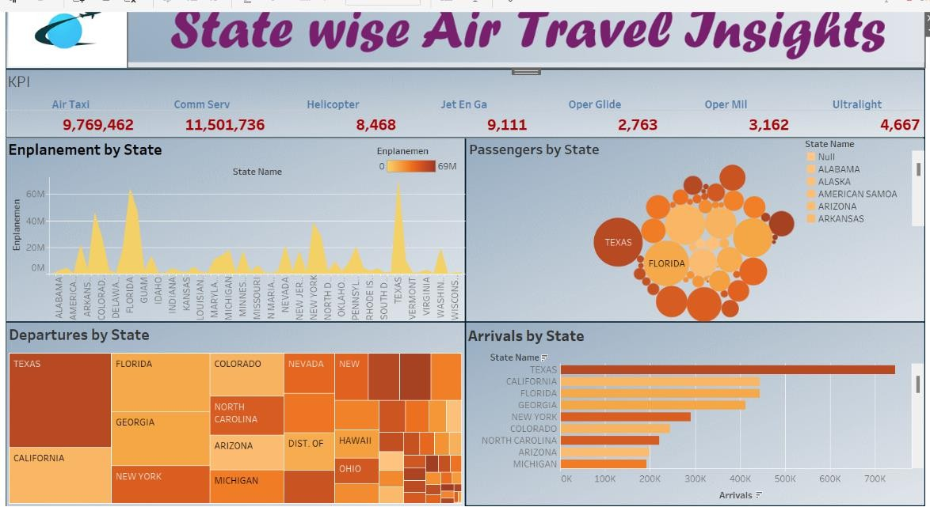

The most air transport passengers are in Texas, according to the dashboard. The graph named “Enplanement by State” shows this by giving Texas an extremely tall peak in comparison with other states’ peaks. Texas too has high levels of activity on passenger traffic as well as arrivals/departures when compared to any other state. In the bubble chart that represents Passengers by State, Texas has one of the largest circles which indicates a large number of departures while Departures by State treemap displays wide rectangle shape depicting many numbers leave from there. Also showing a long bar for arrivals at airports within it being shown as being extensive lengthwise across all others states bars in this regard is therefore not surprising but rather expected.

**Third Dashboard: Regional Accessibility and Economic Activities**

# How do Aircraft Landing Facilities Impact Regional Accessibility and Economic Activities? Viz - 1: Number of Facilities State-wise

Understanding the distribution of airport landing facilities and their impact on local accessibility and economic growth is the primary objective. We can determine which states have a higher density of airports and other landing facilities by mapping these facilities, which may improve accessibility and stimulate economic growth.

Interpretation and Understanding

* High Concentration Areas: With several airports for air traffic, states with a high concentration of facilities, the aviation sector most likely drives greater economic activity in these states in the form of freight transport, business travel, and tourism.
* Low Concentration Areas: States with fewer facilities may experience accessibility issues and slower economic growth in aviation-related industries.
* Regional Comparisons: The map also enables regional comparisons, displaying the relative strengths and weaknesses of the aviation infrastructure in the various U.S. regions.

# Viz – 2: Type of Landing facility

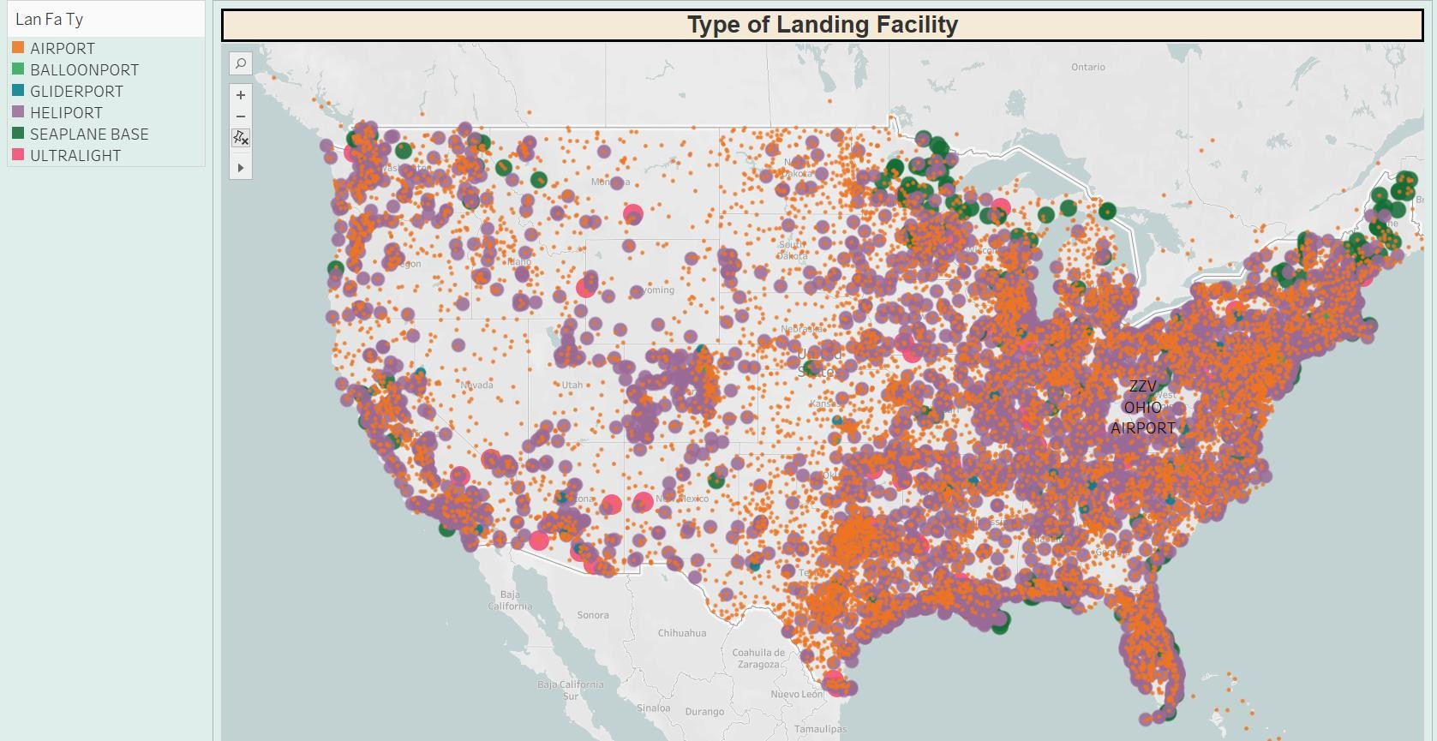

Analyzing the distribution of various aircraft landing facility types—airports, heliports, glider ports, seaplane bases, etc.—across the United States is the aim. This aids in comprehending the ways in which different locations are prepared to manage various forms of aviation activity and air traffic, which is closely related to regional accessibility and the promotion of economic activity.

Interpretation and Understanding

* Facility Diversity: The map shows that a large concentration of airports is located in economically significant and densely inhabited areas.
* Regional Capabilities: Places with a wide range of facility types, such as heliports and seaplane bases by rivers or coasts, indicate a customized infrastructure that meets particular regional demands and may even strengthen local economies by attracting tourists and providing quicker, more specialized transportation.

# Viz – 3: Number of Economic Activities

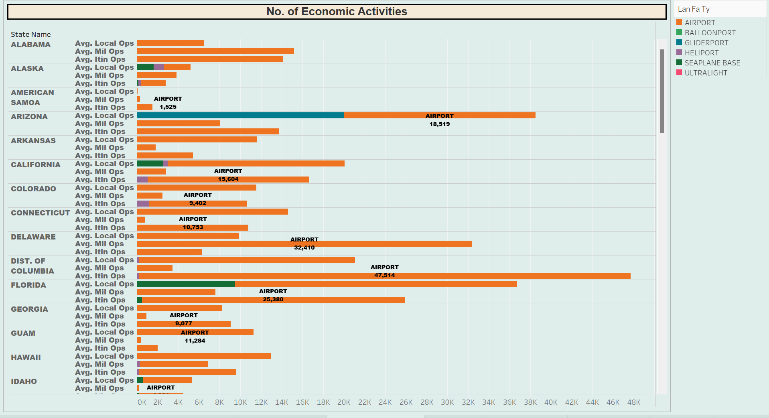

Quantifying the economic activity linked to various kinds of airplane landing facilities in each state is the main objective. The analysis tries to evaluate how these facilities contribute to economic vibrancy and accessibility within the regions by focusing on typical local, military, and itinerant operations

Accessibility and Economic Impact: High Numbers of Operations: States having a high number of operations in any category usually have a strong aviation-related economy. Texas and California, for instance, display significant numbers indicating a high level of economic involvement with aviation.

# Viz – 4: Nearest Central Business District (CBD)

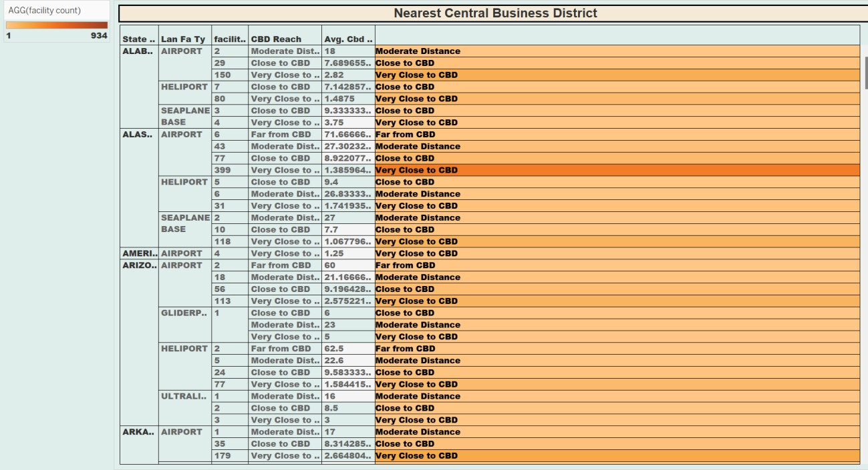

The main goal is to evaluate how close different kinds of aircraft landing facilities (such as seaplane bases, heliports, and airports) are to central business districts, since this closeness can have a big impact on the connectivity and local economic development.

Interpretation and Understanding Effect on the Level of Accessibility:

* Trends in Proximity: Because they are easier to reach, facilities near central business districts (CBDs) are usually more convenient for business travelers and may stimulate the local economy. For example, heliports near central business districts (CBDs) might serve mainly emergency or business services, improving urban mobility.
* Different States by State: The closeness of facilities near CBDs varies significantly between states, as the chart illustrates.
* Distribution of Facility Types: Another important factor influencing the economic impact of a facility is its kind. While ultralight or gliderport airports may serve more niche or recreational markets, airports in central business districts (CBDs) can accommodate larger-scale commercial operations.

**Dashboard** - Regional Accessibility and Economic Activities

# How do Aircraft Landing Facilities Impact Regional Accessibility and Economic Activities?

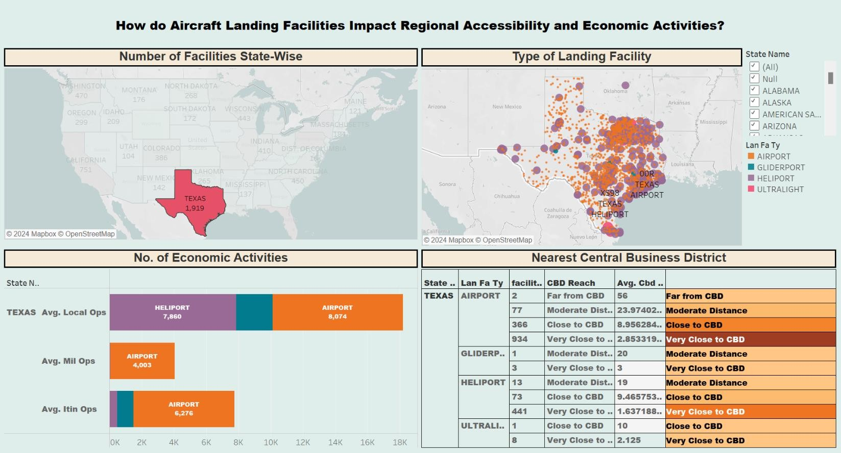

With an emphasis on Texas, the dashboard offers a thorough analysis of how airport landing facilities affect local accessibility and economic activity nationwide. This is an integrated examination of how this dashboard's relationship between the different graphics helps to clarify the main query. The dashboard allows users to dive down and examine particular facts of interest thanks to interactive filters like "State Name" and "Lan Fa Ty" (kind of landing facility). For instance, choosing "Texas" and various facility kinds can provide specific insights on how each kind of Texas facility affects the state's total aviation activity and economy.

Insights

With regard to Texas specifically, we can observe that it has the greatest number of landing facilities (1,919) of any state, suggesting a substantial potential for economic impact because of its extensive aviation infrastructure. Texas boasts outstanding operation counts as well; just airports report significant local (8,074), military (4,003), and itinerant (6,276) activity counts.

Given the volume of activity, it appears that Texas' airports serve as essential hubs for both regional and global connectivity.

Several facilities are 'Very Close to CBD' or 'Close to CBD,' according to the proximity data, which improves accessibility for economic activities and establishes Texas as a crucial state for business and commerce involving air travel. The existence of diverse facilities, such as heliports, gliderports, and airports, each varying in proximity to CBDs, suggests a diverse and robust infrastructure supporting different needs—from commercial to private aviation, enhancing regional accessibility further.

Conclusion

The dashboard tells the tale of the economic and accessibility impact of aircraft landing facilities by skillfully tying together the quantity, kind, and operating intensity of these facilities with their proximity to important business centers. According to the statistics, Texas has a robust infrastructure that can sustain a wide range of economic operations because of its high accessibility and variety of facility types that can accommodate different aviation needs. This arrangement probably makes the area much more accessible and economically dynamic, establishing Texas as a major participant in the US aviation industry.

**Fourth Dashboard: Operational Capabilities and Aviation Support**

# Operational Capabilities and Aviation Support at U.S. Landing Facilities Viz – 1: Operations Capabilities

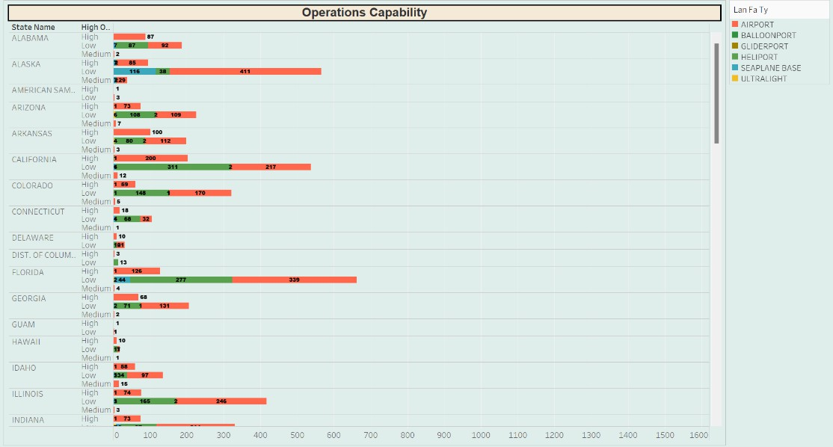

This chart's goal is to evaluate the operating capacities of airfield landing facilities in each of the 50 states of the United States, divided into three operational levels: high, medium, and low. The ability of each state's aviation infrastructure to accommodate a range of aviation-related needs and activities is determined in part by this analysis.

Analysis

Facilities in each state are grouped according to the chart's operating capacity to handle different sorts of traffic and services. The number of facilities under each operating category is visually represented by the length and color of each bar segment, giving a clear picture of how states differ in terms of their ability to support aviation.

# Viz – 2: Aviation support

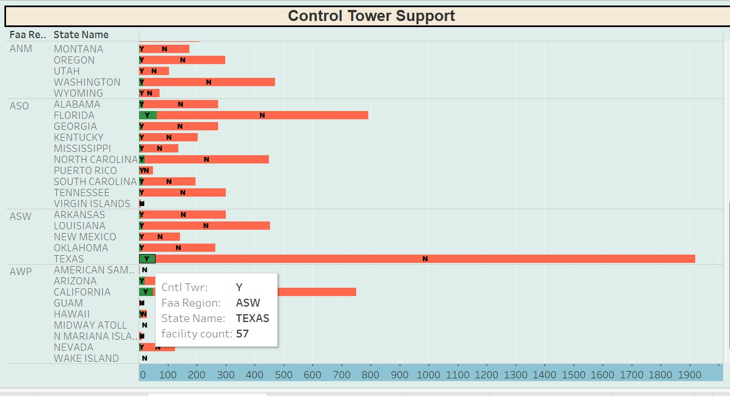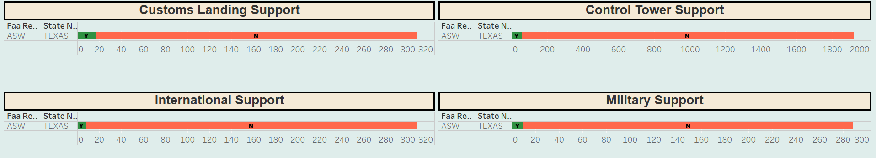

In order to illustrate how these infrastructure components may affect the operational capabilities and safety of air traffic management in certain places, this figure examines the presence of control towers at aircraft landing sites throughout different FAA regions and states.

Analysis

Each bar in the bar chart format used in the image represents a state within a certain FAA area. Depending on whether the facilities in that state have control towers, the bars are color-coded ("Y" for yes in green and "N" for no in red). The bar's length provides a rapid comparison of the amount of aviation infrastructure between states by indicating the number of facilities in each state.

In the same way we can perform other visualizations for aviation support with international, customs landing right, Military support.

# Dashboard - Operational Capabilities and Aviation Support

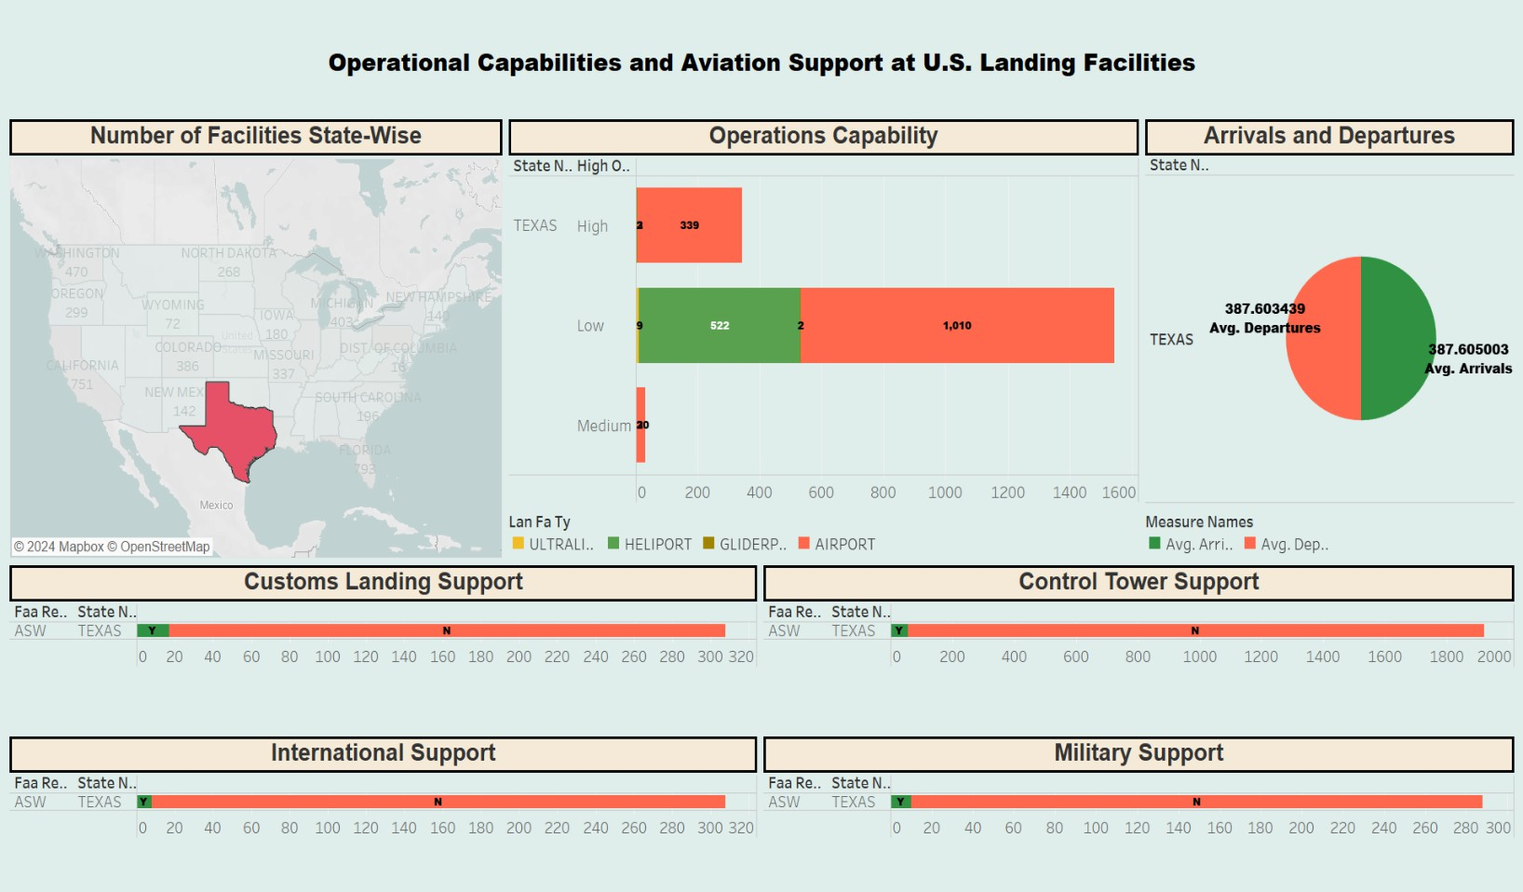

With an emphasis on Texas, the dashboard offers a comprehensive picture of the operational capabilities and aviation support at U.S. landing grounds. In addition to arrivals and departures data, it incorporates a number of data visualizations to examine facility distribution, operational capacity, customs and international support, and control tower presence. Users can tailor the data display by selecting interactive filters, such as "State Name" and "Faa Region," which let them to focus on particular states or areas and evaluate their aviation infrastructure in detail.

Examining the connections between the facility distribution and operations capability charts Together, the map and bar chart display the locations of the facilities and their capacities. This sheds light on how well-prepared various locations are to manage fluctuating air traffic volumes and operational demands.

Operational Efficiency and Volume of Traffic: The operational capability (bar) chart and the arrivals and departures pie chart are closely related because a state's capacity to effectively manage a given volume of air traffic is directly correlated with its operational capability level. Greater traffic volumes are correlated with higher operational capacity, which affects regional connectivity and economic activity.

Support Services: Additional insight into the infrastructure's capacity to manage intricate operations, such as international flights and compliance with safety and regulatory requirements, is provided by the charts that show customs landing support, international support, and control tower presence.

Military Support: The strategic significance of specific sites may be impacted by the existence of military support at facilities, which may suggest additional operational capabilities not reflected in commercial data alone.

To sum up, the dashboard does a good job of combining many facets of aviation operations and infrastructure, giving a clear image of Texas's capabilities and its critical role in promoting aviation-related regional and national economic activity.

**Fifth Dashboard: Analysis on each Landing facility Type**

# Analysis on individual Landing Facility Types and Its elevation and performance

**Viz – 1: Landing Facility type**

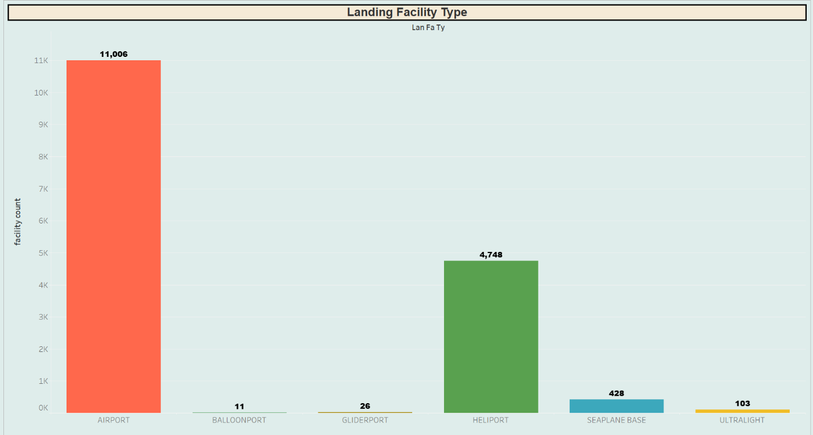

This chart's goal is to offer a quantitative study of the many kinds of landing facilities found in the dataset, classifying each according to the kind of operation it supports—airports, heliports, seaplane bases, etc. In order to provide insights into the diversity and specialization of the infrastructure in aviation services, the analysis attempts to illustrate the distribution and predominance of each type of facility.

Analysis

The number of each kind of landing facility is shown in a bar chart, with different colors designating the various facility types for easy distinction. It is easy to determine which facility types are rare and which are more common thanks to the visual comparison between categories.

# Viz – 2: Elevation Analysis

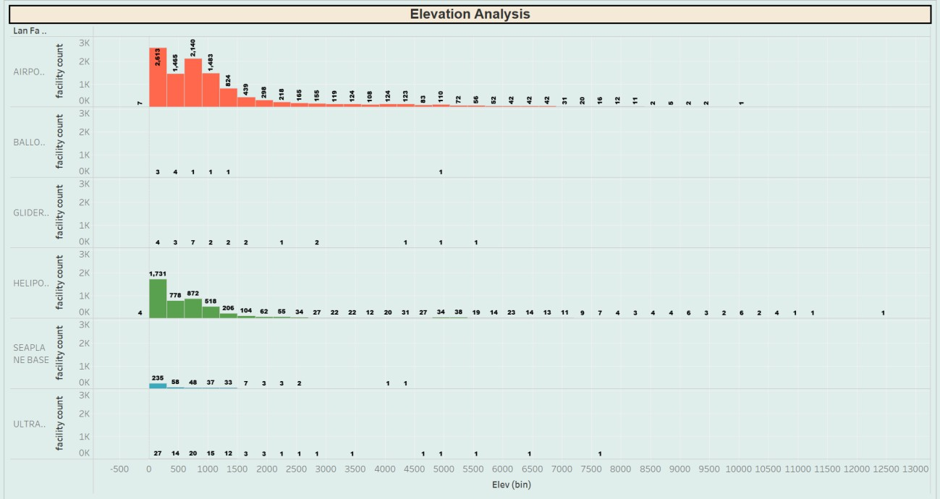

This visualization is a segmented bar chart analyzing the elevation of various types of aircraft landing facilities. The horizontal axis represents elevation bins, grouped into intervals to display the count of facilities at varying altitudes. The vertical axis indicates the count of landing facilities within each elevation bin. There are different types of landing facilities categorized by color. The categories include airports, balloon ports, glider ports, heliports, seaplane bases, and ultralight facilities. Each bar's height corresponds to the number of facilities within a specific elevation range for each type, providing a clear comparison of facility distribution by altitude. The dominant category appears to be airports (in orange), with the highest number of facilities situated at lower elevations. There's a notable decrease in airport count as elevation increases. Heliports (in purple) also show a similar pattern but with fewer counts overall.

There are very few balloon ports, glider ports, seaplane bases, and ultralight facilities, and these are generally located at lower elevations. In particular, balloon ports and ultralight facilities are so few in number that they appear only in the lower elevation bins. At the higher end of the elevation spectrum (beyond 7,000 feet), we see only one instance in each of the airport, heliport, and seaplane base categories. This kind of elevation analysis is crucial for aviation planning and safety management as it helps understand where certain types of aircraft operations are more

prevalent and could potentially inform infrastructure development and emergency response planning related to aviation facilities.

# Viz – 3: Ownership

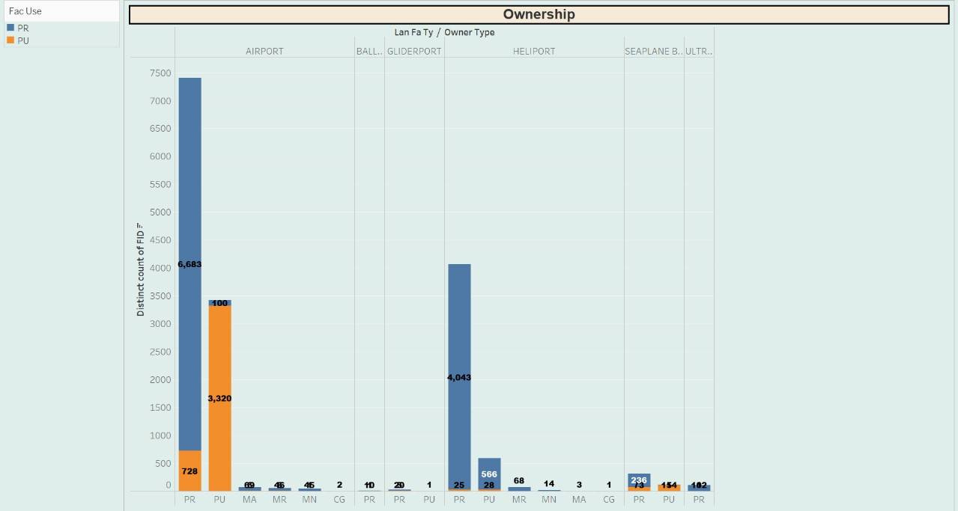

Airports have the highest number of facilities, with public (PU) ownership being the most prevalent, followed by private (PR), and a small segment of military (MA) ownership. Heliports are the next most numerous, with a significant number of public (PU) facilities, a considerable amount of private (PR) ones, and a few military-related facilities. Seaplane bases show a majority of public (PU) ownership, with a small portion of private (PR) ownership. Balloon ports, glider ports, and ultralight facilities are relatively scarce compared to airports and heliports are mostly privately owned. The numerical labels on the bars indicate the exact count of facilities for each segment, providing a precise understanding of the data. This type of visualization helps in quickly identifying the distribution of facility types by ownership and use, which can be valuable for policymaking, infrastructure development, and investment decisions in the aviation sector.

# Viz – 4: Operations Type

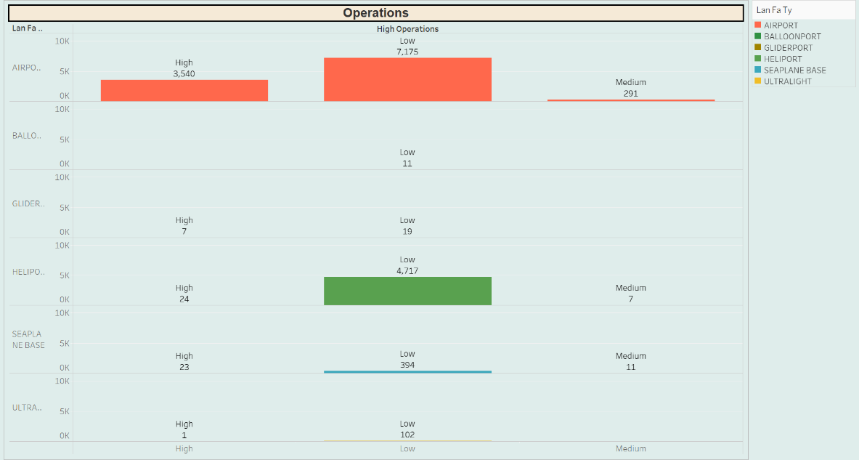

An investigation of the operational activity levels at different kinds of landing facilities is shown in this graphic. It divides the operating operations across several facility types, including airports, heliports, gliderports, seaplane bases, balloonports, and ultralight strips, into three levels: high, medium, and low. The analysis's goal is to provide light on these facilities' level of activity, which will aid in comprehending their place in local transportation systems, their economic significance, and their capacity to manage varying air traffic levels.

# Dashboard - Analysis on each Landing facility Type

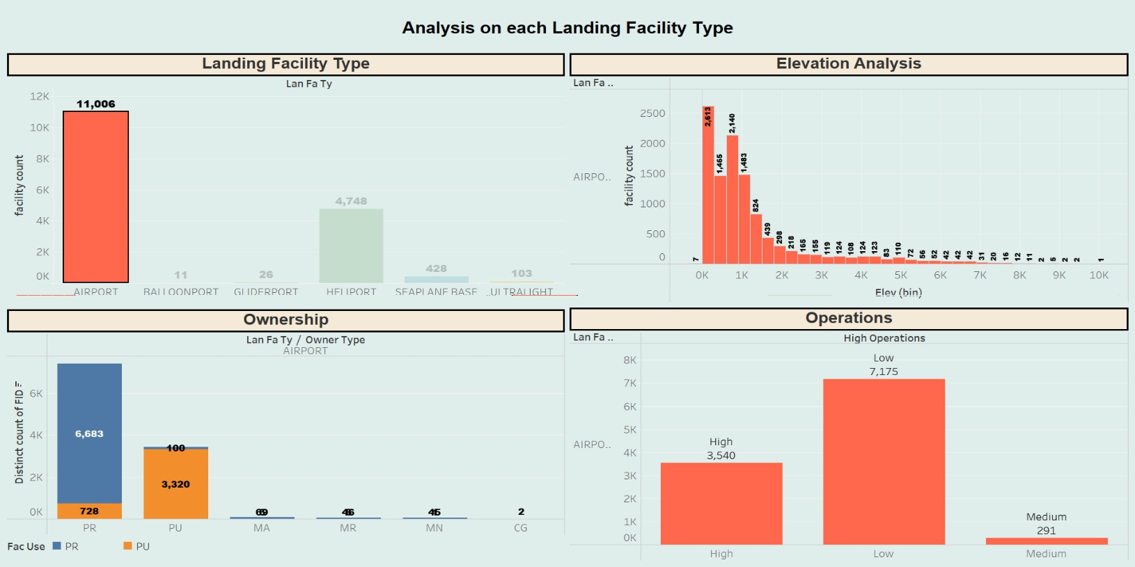

This extensive dashboard examines the distribution, operational capabilities, ownership kinds, and geographic features (such as elevation) of landing facilities by integrating many data sources. Together, the distinct insights from each graphic offer a comprehensive knowledge of the difficulties and capabilities of the aviation infrastructure.

Charts' Relationships to Operations and Facility Type: The relationship between landing facility types and their operations demonstrates how various facility types are used in response to traffic volume. Due to their extensive activities, airports play a vital role in both national and regional transportation networks.

Ownership and Type of Facility: The relationship between facility categories and ownership types demonstrates how different types of operational management—public, private, military, etc.—can affect the capacity and function of a facility. For instance, compared to commercial or military-owned facilities, public airports could have different operating metrics and support capabilities.

Elevation and Operations: The relationship between topographical elements and facility operations can be uncovered through the elevation analysis linked to operational data. those at higher elevations may experience distinct operating capacity issues and constraints than those at lower elevations.

Facility Type and Elevation: This study contributes to our understanding of how the built environment influences the kind of facilities that are constructed. Seaplane bases, for example, are probably located near bodies of water at lower elevations.

Interactive Filters

The "State Name," "Facility Type," and maybe "Operations" filters on the dashboard enable stakeholders to delve deeper and examine particular data subsets. By choosing "Airport" as the example, you may narrow down the study to just airports, giving you detailed insights into the biggest and most important part of the aviation infrastructure.

Finally, with an emphasis on airports, the dashboard offers a thorough understanding of the intricacies of airport management, operations, and geographic positioning, providing insightful information to aviation authorities, politicians, and private industry stakeholders. An intricate picture of how airports are essential to economic vitality and connectivity is painted by the thorough breakdown by operations and ownership under the filter selection. This picture is shaped by a mix of operational intensity, management structure, and geographical variables.

# References

Dataset Source - <https://www.kaggle.com/datasets/thedevastator/usa-aircraft-landing-facilities>

Principles of effective data visualization: [https://www.cell.com/patterns/pdf/S2666-](https://www.cell.com/patterns/pdf/S2666-3899(20)30189-6.pdf) [3899(20)30189-6.pdf](https://www.cell.com/patterns/pdf/S2666-3899(20)30189-6.pdf)

Measuring effective data visualization: [https://link.springer.com/chapter/10.1007/978-3-540-](https://link.springer.com/chapter/10.1007/978-3-540-76856-2_64) [76856-2_64](https://link.springer.com/chapter/10.1007/978-3-540-76856-2_64)

An overview of data visualization: <https://ieeexplore.ieee.org/abstract/document/9012031/>

Data Visualization in the Information Society: <https://mw.saludcyt.ar/index.php/mw/article/view/25>

Principles of effective data visualization: [https://www.cell.com/patterns/pdf/S2666-](https://www.cell.com/patterns/pdf/S2666-3899(20)30189-6.pdf) [3899(20)30189-6.pdf](https://www.cell.com/patterns/pdf/S2666-3899(20)30189-6.pdf)

Measuring effective data visualization: [https://link.springer.com/chapter/10.1007/978-3-540-](https://link.springer.com/chapter/10.1007/978-3-540-76856-2_64) [76856-2_64](https://link.springer.com/chapter/10.1007/978-3-540-76856-2_64)

An overview of data visualization: <https://ieeexplore.ieee.org/abstract/document/9012031/>

Data Visualization in the Information Society: <https://mw.saludcyt.ar/index.php/mw/article/view/25>

---o---